**Backend Deployed In Azure**

Step 1. Need to create Database in Azure

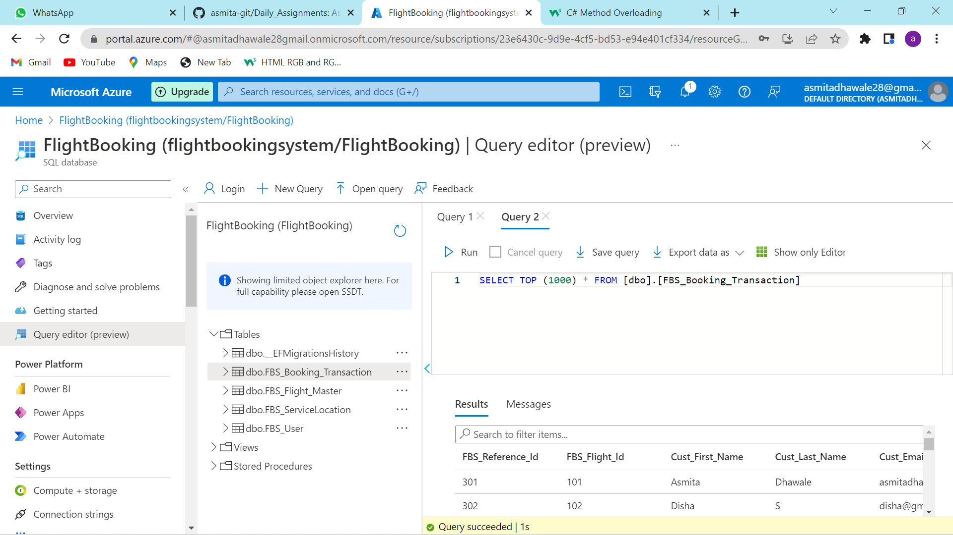

Step2.Open Visual studio and Right click the project and go to publish option select azure deploy and azure app service windows then procced.

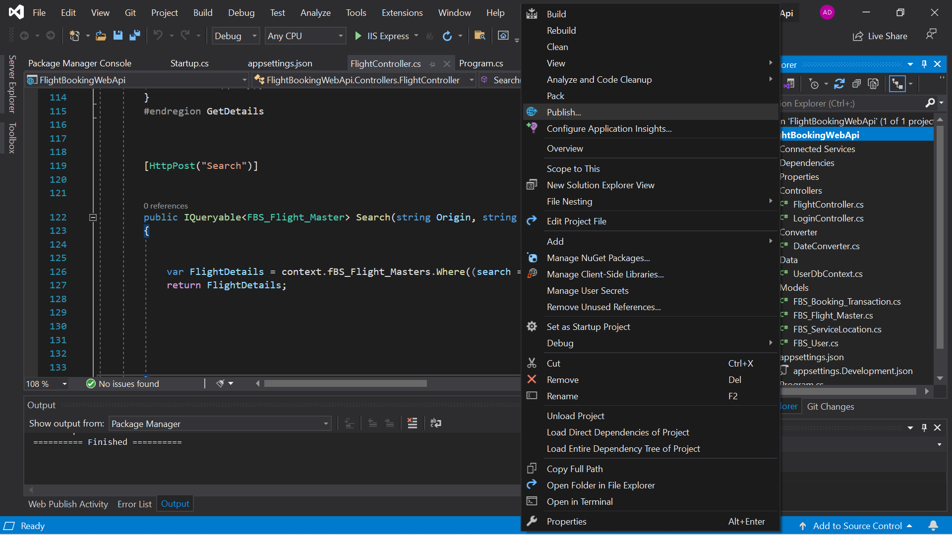

Step4. Then click app services instance Then you have to go to another page

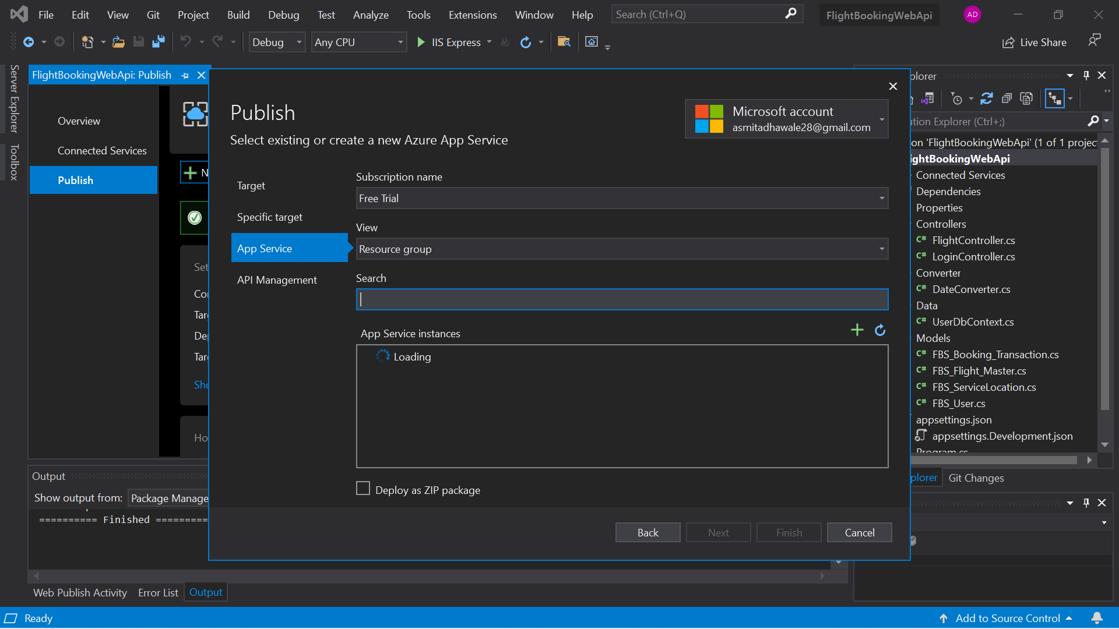

Step 5: Need to select App Services Instance

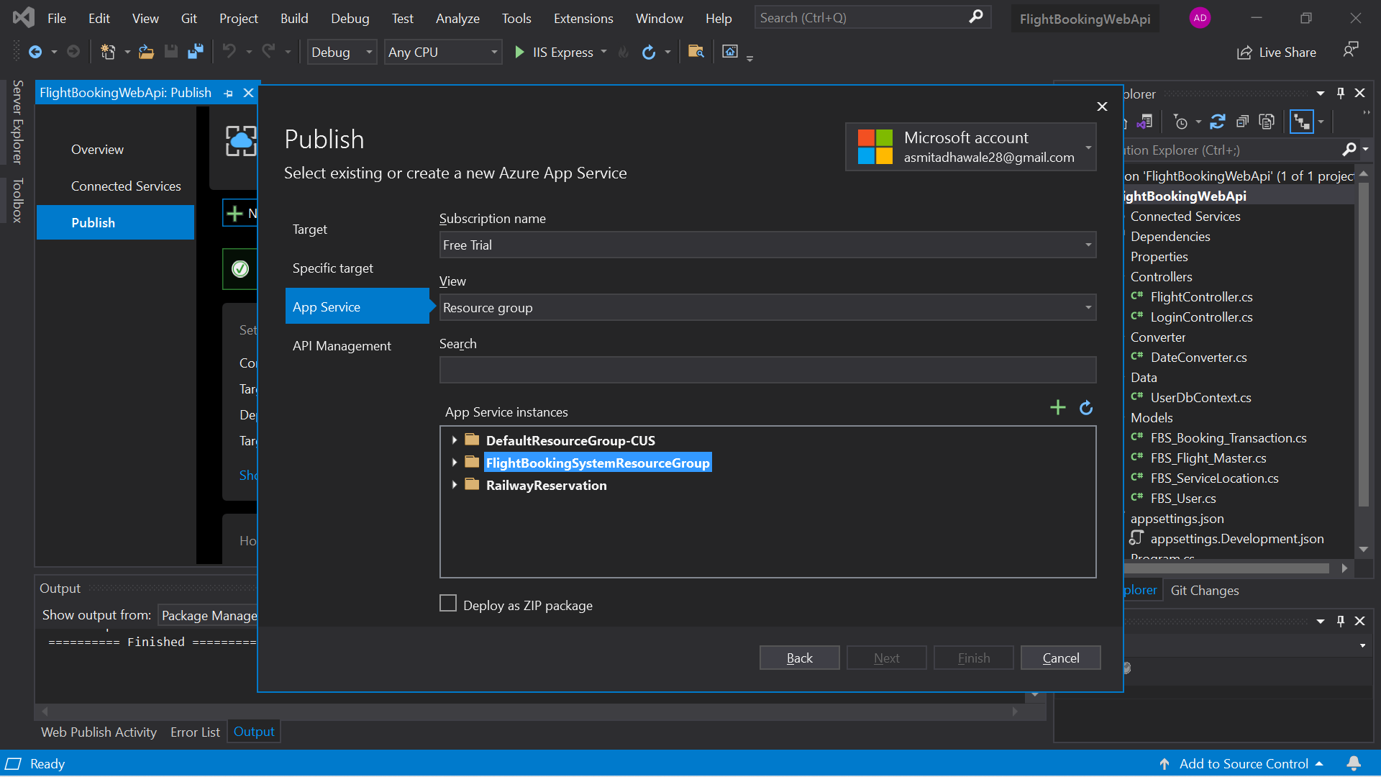

Step 5: Then check this option and click create button

Step 6: Then click the finish option it will be deployed..

After that you will configured your database and then in the above click publish option.

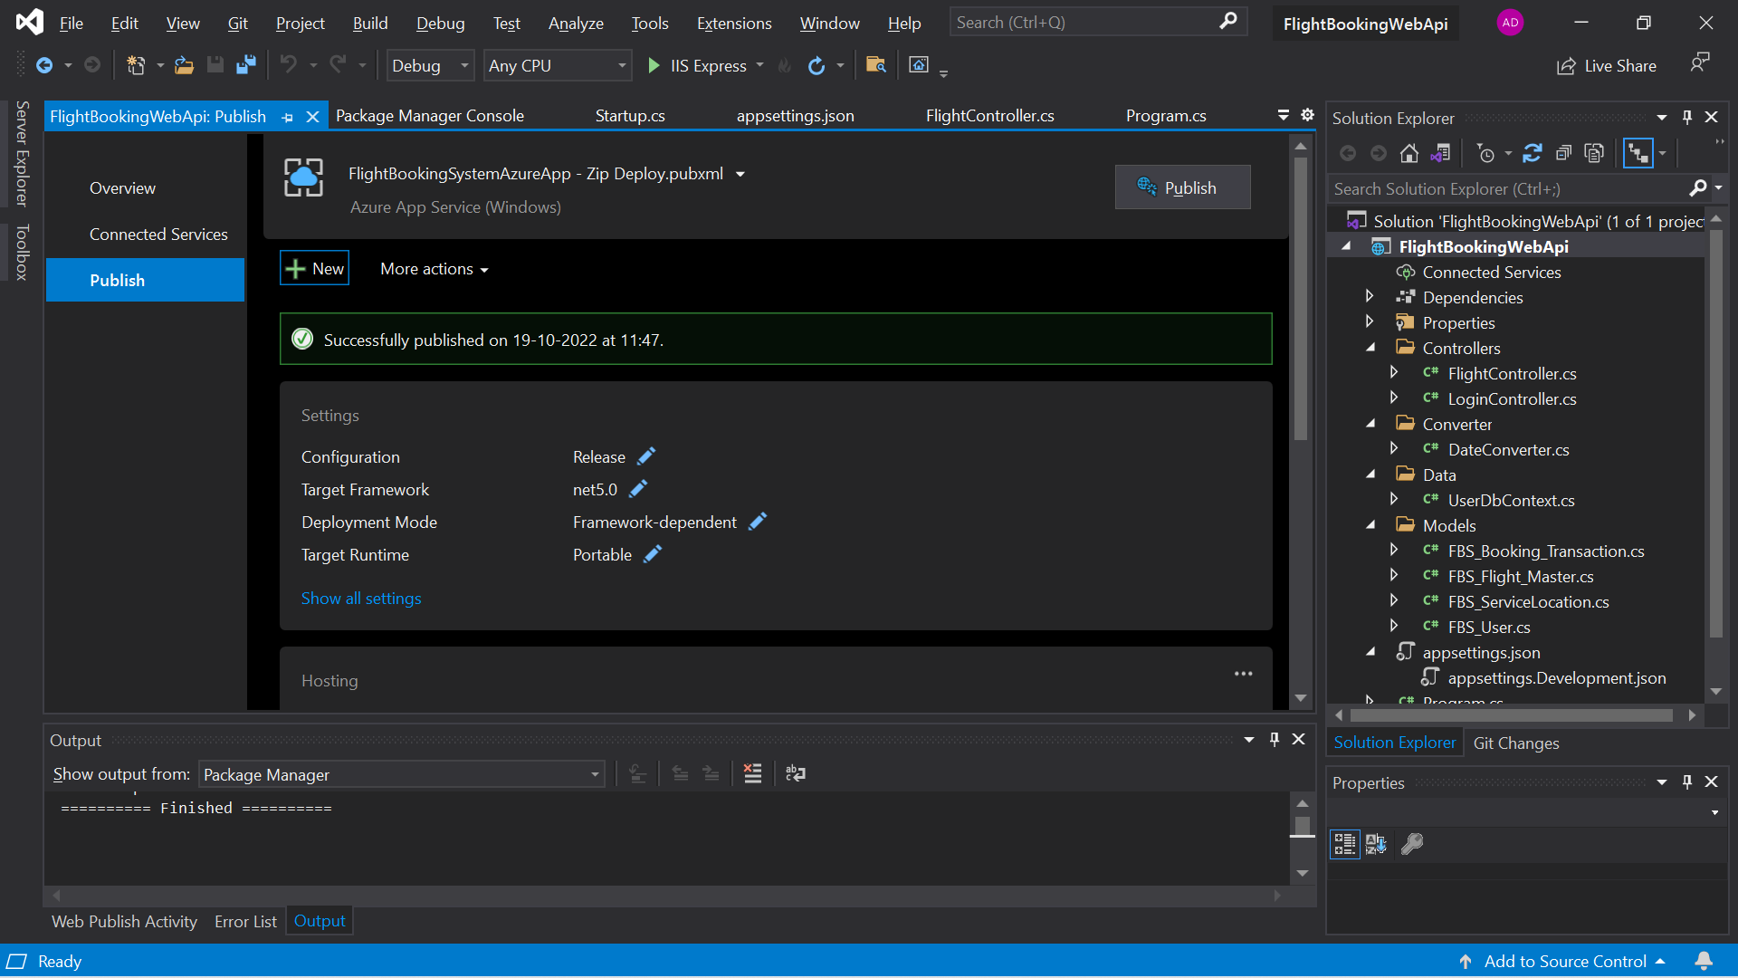

Then you have to check url that is working or not and check Azure portal URL.

Link :<https://flightbookingwebapi.azurewebsites.net/index.html>